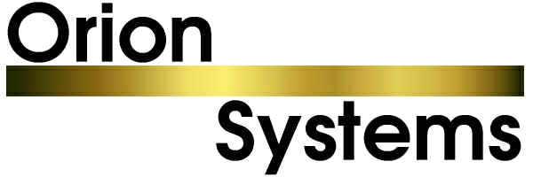

8 January 2007

For Immediate Release

BLUEBIRD INTRODUCES DATA BRIDGE FOR BUDGET RENT A CAR

PRESS RELEASE

Dover, NJ USA. Bluebird Auto Rental Systems (BARS) announced that they have released a “Data Bridge” with Budget Rent a Car which is integrated with Bluebird’s RentWorks vehicle rental software.

The bridge essentially allows a real-time access to the Wizard system, yielding significant benefits: Budget licensees are able to look up corporate rates and customer profiles when making a reservation or opening a rental agreement. One way vehicles can be tracked to other locations participating in the Data Bridge (licensee locations using Bluebird or Orion software or corporate locations using Wizard). Most importantly, rental agreements are transmitted to the Wizard information system and data warehouse. From there, numerous processes are performed on behalf of the licensee to improve the communication among all locations – licensees as well as corporate – with respect to vehicle movement, repeat customers, and corporate accounts.

“The development of the Budget Data Bridge on Bluebird’s RentWorks platform is of enormous benefit to our Budget Rent a Car licensees”, stated Phil Jones, Vice President of Bluebird Auto Rental Systems. “One way rentals are now seamlessly passed from system to system utilizing Orion System’s data bridge to Budget Rent a Car, providing the licensee with real time, accurate, information while giving the renter a superior level of customer service.”

The roll-out of the Data Bridge has already begun. It is anticipated that all licensee locations throughout the U.S. and Canada using Bluebird software will be live by the end of 2007.

About Bluebird Auto Rental Systems
Bluebird Auto Rental Systems is a provider of cost-effective, turn-key computer systems to vehicle rental operations worldwide since 1982. Bluebird’s Auto Rental application software, RentWorks, enables dealerships to more efficiently manage their service loaner fleets – expediting the rental process and improving the overall customer experience. All Bluebird products include 24 x 7 access to their Online Call System, Knowledge Base, and documentation.

On June 1, 2006, Bluebird Auto Rental Systems purchased the assets of Orion Systems, who maintains the Data Bridge for Budget Rent a Car.

www.barsnet.com.

CONTACT:
Angela Margolit
(973) 989-2423
angela@barsnet.com

